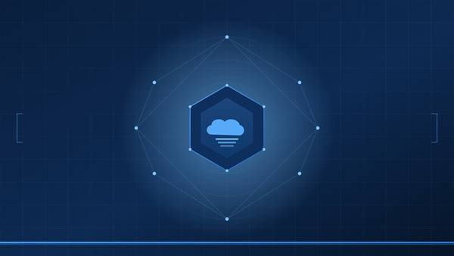
TECHNICAL ADVISORY · PRIVATE CLOUD OPERATIONS
<Project Name>
<VCF Version> / <VCF Automation Version>

Design Document
PREPARED: <Month Year> · AUDIENCE: <customer>, <groups>

1. Goals and Non-Goals

1.1 Goals
<Bulleted list of what the solution MUST accomplish. Be specific and measurable.>
- <Goal 1>
- <Goal 2>
- <Goal 3>
- <Goal 4>
- <Goal 5>

1.2 Non-Goals
<Bulleted list of what the solution explicitly does NOT do. This prevents scope creep and sets expectations.>
- <Non-goal 1>
- <Non-goal 2>
- <Non-goal 3>
- <Non-goal 4>

2. Architecture Overview
<Describe the solution architecture: what type of artifact it is (workflow, package, etc.), how many elements it contains, what runtime(s) it uses, and how data flows between elements.>

2.1 Pipeline
<Table listing each workflow element (scriptable tasks, decision elements, exception handlers) with ID, name, and responsibility.>
ID | Task | Responsibility
<ST-01> | <Task name> | <What this task does>
<ST-02> | <Task name> | <Responsibility>
<ST-03> | <Task name> | <Responsibility>
<ST-04> | <Task name> | <Responsibility>
<EH> | <Exception Handler> | <Error classification and lock release>

2.2 Action Modules
<Table listing each action module and the actions it contains.>
Module | Actions
<com.broadcom.pso.category.subcategory> | <Action names and descriptions>
<com.broadcom.pso.category.subcategory> | <Action names and descriptions>

3. Configuration Model
<Describe all configuration elements, workflow variables, and workflow inputs. Include type, default value, and purpose for each.>

3.1 Configuration Element Attributes
Attribute | Type | Purpose
<attribute name> | <string/number/boolean> | <What it stores and how it is used>
<attribute name> | <type> | <Purpose>

3.2 Workflow Variables
Variable | Type | Default | Notes
<variable name> | <type> | <default value> | <Usage notes>
<variable name> | <type> | <default> | <Notes>

3.3 Workflow Inputs
Input | Type | Default | Notes
<input name> | <type> | <default> | <Notes>
dryRun | boolean | true | MUST default to true.

4. Concurrency and Locking
<If applicable: describe how the solution prevents concurrent execution, what locking mechanism is used, how locks are acquired and released, and what happens on abnormal exit. Remove this section if not applicable.>

5. Core Algorithm / Processing Logic
<Describe the core logic of the solution. This is the technical heart of the design document. Include decision rules, data flow, ordering logic, safety checks, metric collection methods, etc. Use subsections (5.1, 5.2, ...) to break up complex logic. Include callout boxes for important edge cases.>
<Edge case title>
<Explanation of why this edge case matters and how the design handles it.>

6. Per-Item Safety Checks
<If applicable: table listing each safety check performed before the destructive/modifying operation, with the skip/fail reason logged when the check fails.>
Check | Skip/Fail reason
<Check 1> | <What is logged and why>
<Check 2> | <Reason>
<Check 3> | <Reason>

7. Logging and Observability
<Describe the logging architecture: marker format, run ID correlation, structured output format. Include a sample JSON output block if the workflow produces machine-readable output.>

7.1 Marker Architecture
<Describe the log line format: [SHORT-NAME] [PHASE] [STATUS] message>

7.2 Run ID Correlation
<How individual log lines are traced back to a specific run.>

7.3 Structured Output
<Sample JSON or structured output written to workflow output attributes.>

8. Known Issues and Technical Debt
# | Item | Description
8.1 | <Issue title> | <Description and any workaround>
8.2 | <Issue title> | <Description>

9. Failure Modes and Outcomes
Outcome | Set by | Meaning
<SUCCESS> | <Element ID> | <Description>
<DRY_RUN_COMPLETE> | <Element> | <Description>
<ERROR> | <Element> | <Description>

10. Design Trade-offs
<Document the major design decisions and why alternatives were rejected. Use prose paragraphs with descriptive sub-headings. This section is critical for future maintainers who will ask "why was it done this way?">

11. Future Work
<Bulleted list of enhancements that are out of scope for the current release but planned or considered.>
- <Future enhancement 1>
- <Future enhancement 2>
- <Future enhancement 3>

